Italy

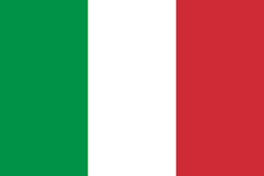

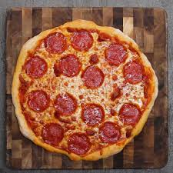

By Lee Elder

Class 2.6

Contents

1. Introduction
2. Food and its origins
3. Culture
4. Climate
5. General facts (currency,population etc.)

Introduction

Italy is a country in Europe. Its neighbouring countries are France, Switzerland, Austria and Slovenia. Italy has had a big influence on Western culture and food. Its capital, Rome, is where you can find the Vatican as well as some ancient ruins. Other big cities in Italy include Florence, Venice which is nicknamed “the city of canals” and Milan, Italy’s fashion capital.

Italian food, and its origins

Pizza started off as baked flatbreads topped with olive oil and spices and was eaten by ancient romans and greeks. Today, we call this dish focaccia bread.

The pizza we know that has tomato sauce, cheese, and toppings? That started off in Italy. A baker named Raffaele Esposito from Naples is often given credit for making the first pizza like this. Historians say, however, that street vendors in Naples sold flatbreads with toppings for many years before then.

Italian King Umberto I and Queen Margherita visited Naples in 1889. There, the baker was asked to make them a pizza. He topped the pizza with fresh tomatoes, mozzarella cheese, and basil. That pizza is still known as Pizza Margherita today.

Another popular italian food is spaghetti bolognese. The earliest documented recipe for a meat-based sauce served with pasta comes from late 18th century Imola, near Bologna.

Pellegrino Artusi published a recipe for a meat sauce characterized as being bolognese in his cookbook published in 1891. Artusi's recipe, which he called Maccheroni alla bolognese, is thought to have come from the mid 19th century when he spent considerable time in Bologna.

Culture

The Italian culture is commonly associated with art, music and food. The major religion in Italy is Roman Catholicism. Vatican City, located in the heart of Rome, is the hub of Roman Catholicism and where the Pope resides. Roman Catholics and other Christians make up 80 percent of the population, though only one-third of those are practicing Catholics. The women wear colorful embroidered skirts and bodices over light-weight chemises or blouses, with elaborate hats decorated with flowers or fruit. Men's traditional clothing tends to be simpler, but doesn't lack from attention to detail, with embroidery and metal buttons and pins. These costumes evolved from simpler peasant dress in the Middle Ages.

Italian peasants wore practical clothing for their daily activities, with simple pants and shirts for the men and blouses and skirts for the women, sometimes with a bodice. Most items were made from simple fabrics, wool being very common. Color selection was limited to inexpensive gray and black dyes. One notable traditional Italian fabric is a waterproof type of wool called orbace.

Climate

With its hot, dry summers and cool, wet winters, Italy experiences a mediterranean climate. Winters in Italy are cool and humid in the north and the areas with lots of mountains. In the summer winds can bring very hot, unpleasant weather, sometimes even up to the northern districts of Italy.

General country facts

Currency: The italian currency is Euros(€) as used by most european countries. One Euro is equivalent to £0.87

Population: 60,550,075

Conclusion

Italy is a great place with fascinating culture, food and history. Most importantly, it has also influenced quite a lot of our culture and food in scotland (pizza for example). Who doesn’t love a good old pizza.